**CHAPTER 4**

**RESULTS AND DISCUSSION**

**4.1) REGARDING PARAMETERS**

**Table 1 –** Unknown Parameters for N = 3

|  |  |  |  |  |  |
| --- | --- | --- | --- | --- | --- |
|  | **NaCl** | **LiCl** | **Li2SO4** | **MgSO4** | **CaCl2** |
| **a** | 79.25810001 | -13416.83325 | 1805.607702 | 41812.72232 | 6917.205725 |
| **b** | 0.392577746 | -13655.82569 | -1.52985731 | -1710403.759 | -2045.137046 |
| **c** | 406.7499327 | 1438.11892 | -162.818885 | -124710.7606 | -40191.75976 |
| **d** | 79.25813745 | -17830.20198 | 1804.459355 | 25437.18659 | 8303.19844 |
| **e** | 0.393322704 | 1813.197152 | -1.53831223 | -1693135.758 | -6.0165132628 |
| **f** | 406.7499327 | 1840.796406 | -314.8768451 | 114649.0606 | 38116.51935 |
| **g** | -461.7558628 | 216895.324 | -16834.84598 | -49205.42678 | -55686.377 |
| **h** | -1.299947942 | 15369.79572 | -5.859168109 | 3900142.407 | 1578.732542 |
| **i** | -2712.455354 | -25218.75124 | -5264.96013 | 5674.916688 | 7106.784597 |
| **j** | -286.6609284 | -200587.7443 | -73341.05538 | -57730.37146 | 109013.936 |
| **k** | -0.825744651 | -92.36609842 | -3.144404132 | 75602.14676 | -3999.432868 |
| **l** | -1677.795905 | 6619.358175 | 4942.140603 | 4823.346649 | -22960.88857 |

**Table 2 –** Unknown Parameters for N = 4

|  |  |  |  |  |  |
| --- | --- | --- | --- | --- | --- |
|  | **NaCl** | **LiCl** | **Li2SO4** | **MgSO4** | **CaCl2** |
| **a** | -0.212294839 | -8475.14118 | 1583.531513 | 735.2502247 | 8261.720861 |
| **b** | -335.4371663 | 1.951984408 | -1.523361753 | -0.791706136 | 0.574569962 |
| **c** | 10342.4994 | 11063.71503 | 335.0484774 | -175.5402835 | -2205.145069 |
| **d** | -0.207433846 | -8762.679933 | 1586.790475 | 735.2499917 | 8514.638057 |
| **e** | -323.2401916 | 1.945589229 | -1.521177232 | -0791302324 | 0.57414814 |
| **f** | -35421.30669 | -5249.227446 | 309.9047436 | -175.5427682 | 637.5750879 |
| **g** | -4.150170132 | 139528.488 | -21459.34288 | 6263.204201 | -64139.42738 |
| **h** | 357.187306 | -2.140533011 | -5.649620842 | -1.789600289 | -1.661789026 |
| **i** | 3024.992372 | -42267.20539 | -16192.5649 | -3417.892075 | 1822.071307 |
| **j** | -1.176700102 | -28829.39158 | -51230.10337 | -10121.37875 | 119035.627 |
| **k** | 9279.052789 | -3.087335404 | -3.048952414 | -1.185368643 | -1.257998805 |
| **l** | 0 | 49056.73421 | 52595.85194 | 2229.518494 | -1687.598625 |
| **m** | 102073.3323 | -139583.3918 | -4265.223202 | -1750.261638 | 5734.631344 |
| **n** | -0.353976317 | -2.475147526 | -1.159889792 | -0.569492703 | -0.617783764 |
| **o** | -33101.67039 | -35949.50214 | -78519.87037 | -6399.459638 | -28747.96172 |

**4.2) PARITY PLOT GRAPHS**

1. **NaCl**

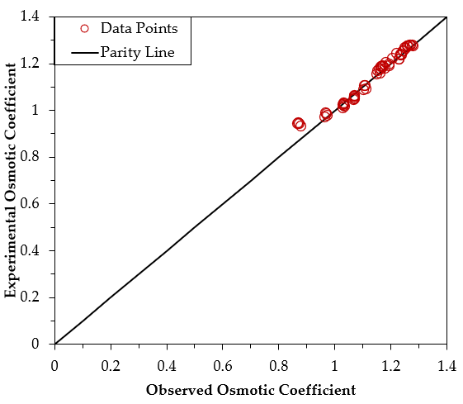

Fig 1. Parity plot of NaCl for N=3

Fig 2. Parity plot of NaCl for N=4

1. **LiCl**

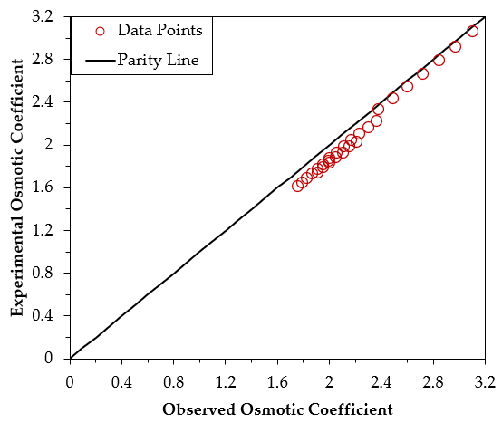

Fig 3. Parity plot of LiCl for N=3

Fig 4. Parity plot of LiCl for N=4

1. **CaCl2**

Fig 5. Parity plot of CaCl2 for N=3

Fig 6. Parity plot of CaCl2 for N=4

1. **Li2SO4**

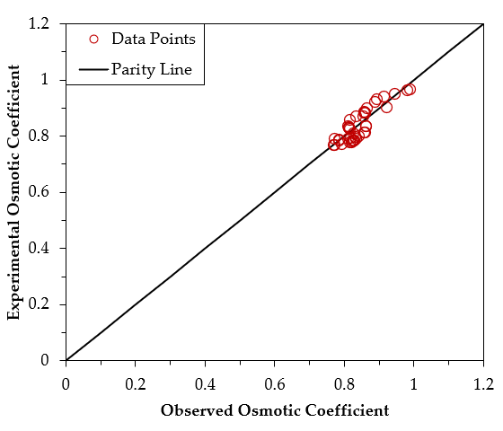

Fig 7. Parity plot of Li2SO4 for N=3

Fig 8. Parity plot of Li2SO4 for N=4

1. **MgSO4**

Fig 9. Parity plot of MgSO4 for N=3

Fig 10. Parity plot of MgSO4 for N=4

**4.3) PHASE DIAGRAM GRAPHS**

1. **NaCl**

Fig 11. Temperature vs Volume fraction of NaCl

Fig 11 represents the phase diagram of NaCl + H2O system. The diagram shows areas that represent a particular mixture of salt of NaCl and water at a given temperature. The point at a temperature of 253K is called eutectic point, which is the lowest temperature at which a liquid phase is stable at a given pressure. It's when a solid solute, a solid solvent, and a liquid mixture all exist in the same phase. The eutectic point is also known as the eutectic temperature and is the lowest possible melting point over all of the mixing ratios of the constituents. The temperature range of 253K to 272K represents the NaCl.2H2O + liquid system which means that you have a rock salt crystal with water molecules as a kind of dissolved impurity (2H2O molecules occupying the place of one NaCl unit), whereas the temperature this represents the NaCl + liquid system. The complete solid – liquid equilibrium data is traced almost exactly with experimental values for both N=3 and N=4 lines.

1. **LiCl**

Fig 12. Temperature vs Volume fraction of LiCl

Fig 12 represents the phase diagram for LiCl + H2O system. Besides anhydrous LiCl, there exist four solid lithium chloride hydrates, with respectively 1, 2, 3, and 5 water molecules. These salts are extremely soluble in water. For example, the solubility of the monohydrate LiCl.H2O is about 20 mol/kg of H2O in pure water at 273 K. At the eutectic temperature of the LiCl + H2O system (199 K), which is one of the lowest of all alkali + water or alkaline earth + water systems, the stable solid is the pentahydrate LiCl.5H2O. Despite this very low temperature, the concentration of the saturated solutions is very high, 24% volume fraction of salt at the eutectic. The calculated liquidus in the LiCl + H2O system showed good agreement with the experimental results for both N=3 and N=4 lines.

1. **CaCl2**

Fig 13. Temperature vs Volume fraction of CaCl2

Fig 13 represents the phase diagram for CaCl2 + H2O system. Phases at equilibrium for the chemical system CaCl2 + H2O are shown as a function of volume fraction of CaCl2 salt and temperature. There are three solid CaCl2 hydrates of 2, 4 and 6. In which CaCl2.6H2O and CaCl2.2H2O occur naturally and have mineral names which are called as antarctictites and sinjarites respectively. The eutectic point of this system is around 223.5K. Till the volume fraction of 0.4, our model showed an excellent agreement with the experimental data for both N=3 and N=4 lines, above with N=4 line tried to trace almost with the experimental data where N=3 line showed a slight deviation till volume fraction of 0.56.

1. **Li2SO4**

Fig 14. Temperature vs Volume fraction of Li2SO4

Fig 14 represents the phase diagram of Li2SO4 + H2O system. This system depicted a simple curve. There is a slight increase in the solubility of Li2SO4 till the eutectic point of around 250K. Here there exist only one form of hydrate salt which is Li2SO4.H2O. Our model made an excellent argument in terms of tracing the experimental values with our model values for both N=3 and N=4.

1. **MgSO4**

Fig 15. Temperature vs Volume fraction of MgSO4

Fig 15 represents the phase diagram of MgSO4 + H2O system. The phase diagram for the MgSO4 + H2O system is more complex because there are more than three phases that can exist. In addition to the solid, liquid, and gas phases, there are also several hydrate phases. Those different hydrate include a count of 1, 4, 5, 6, 7 and 11 molecules of H2O. The phase diagram for the MgSO4 + H2O system is useful for understanding the behaviour of this system in different conditions. For example, the diagram can be used to determine the conditions at which magnesium sulphate heptahydrate will form or decompose. This information can be used in a variety of applications, such as the production of magnesium sulphate and the desalination of water. Our model gave an excellent result of aligning with the experimental values for both N=3 and N=4. There is a slight deviation from the experimental values in between the volume fraction of 0.0036 till 0.011.

The model calculated phase diagrams of the Li2SO4+H2O, NaCl+ H2O, LiCl+ H2O, MgSO4+ H2O and CaCl2+ H2O systems compared with solubility data reported in literature are plotted in the above graphs. The unknown parameters of the equation 5, which helped us achieve this were tabulated in the table 1 and 2. There were 12 and 15 unknown parameters were there for n=3 and n=4 respectively. As shown in above graphs, most of the solid-liquid equilibria data, i.e. the points on the solubility curve, can be reproduced well using the present comprehensive thermodynamic models. Ice solubility data for all these systems can be accurately predicted even though they were not used in model parameterization.

For NaCl, we were able to exactly map the data against the literature work. We can able to observe minor changes in the temperature with an increase in the volume fraction from 0.02 to 0.15, above with there is a sudden increase in the temperature from 250K till 550K. This shift indicates the reduction in the water molecules attached with NaCl from ice, NaCl.2H2O to NaCl.H2O. Similarly, our model well performed in tracing the graphs for Li2SO4 as shown in the above graphs. There was a slight deviation for CaCl2 between the volume fraction of 0.42 to 0.53, which is a region of 2 H2O molecules attached with it.

The available solubility data of MgSO4 between the volume fraction of salt hydrate from 0.10 to 0.12 and 0.16 till 0.18 are kind of scattered and hard to give a critical evaluation on their reliability. Nevertheless, the model result was not affected by the scattered experimental data significantly in those volume fraction of salt hydrate but gave a regular variation. In the system of MgSO4+ H2O, the solubilities of metastable solid phases MgSO4·4 H2O and MgSO4·5 H2O were also tried to simulate except for those stable solid phases. MgSO4·11 H2O was recognized as stable phase at low temperature, although the solid phase corresponding to its solubilities in early literature were determined as MgSO4·12 H2O.

The difference of eutectic temperature of Li2SO4· H2O +ice between the present model predicted value and that recommended by Linke [76] and Sohr et al. [75] is about 2 K. According to the critical evaluation of Sohr et al. [75], the uncertainty of the eutectic temperature is 2 K. So, in such an uncertainty range, the present model result agrees with the recent recommendation of Sohr et al. [75] well. The eutectic composition of this invariant point predicted from the present model agree with those reported by Linke [76] and Sohr et al. [75] in absolute error 0.6% weight percentage, which is in accordance with the uncertainty reported by Sohr et al. [75] recently.

The parity plot for each salt hydrates explains how well this model has predicted its output compared to the Literature data. Our model almost traced its value with the literature value and gave us the error deviation of less than 4%.